**IOT LAB**

**Program No - 12**

**Program Title – IR BASED SERVO MOTOR CONTROLLER.**

**Aim – Design IR based Servo Motor Controller (Clockwise and counter clockwise).**

**Hardware Required -**

* Arduino Board
* Bread board
* IR Remote
* IR Sensor
* Micro servo
* Jump wires

**Circuit Diagram –**

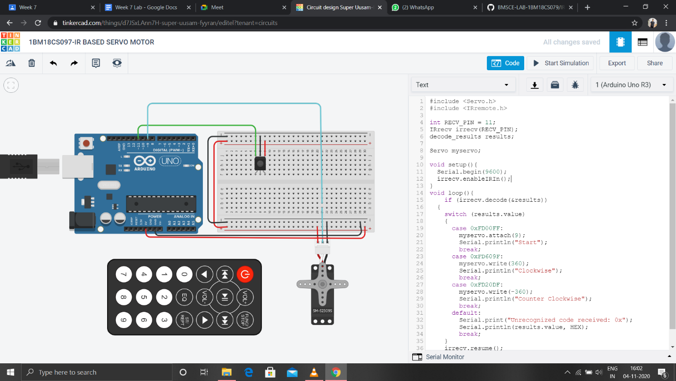

**Code-**

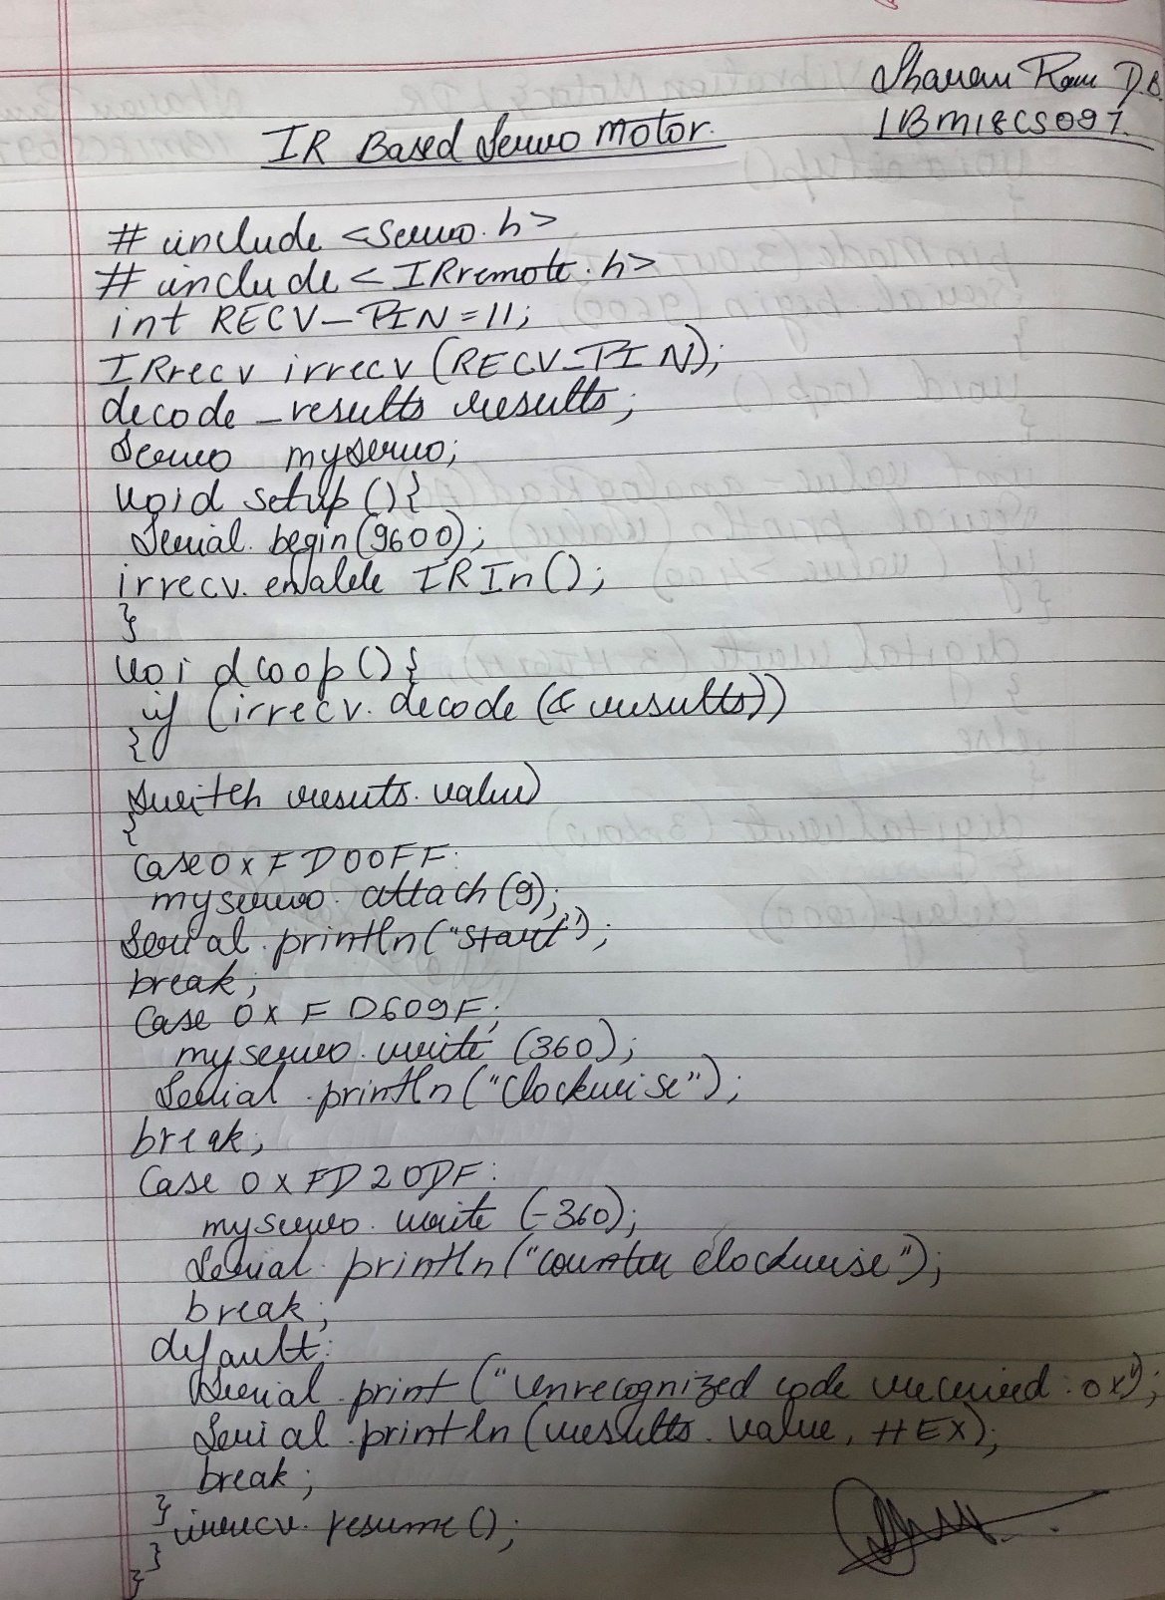

**Observation /Output –**

**The servo motor rotated clockwise and anticlockwise upon the detection of IR signal by the remote.**